Miracle Advance Technologies

DIGITAL EXPERIENCE HEALTH CHECK Vietnam

Application User Manual

Application User Manual 2
1.1. Organization of the Manual 5
1.2. Additional Help 5
1.3. Browser Requirements 6
1.4. Getting Started 6
1.5. Study Worklist 7
1.6. Understanding the Features 7
2. Registration 16
4. BI 16
3. User List 21
4. Locked Worklist 22

Document Version No- 1.1.1

Last update Datetime- 15/12/2021

Last update by-Wasiur Rahman

1.1. Organization of the Manual
The manual is designed to initially familiarize you with the application's most common features, such as dashboards and the search feature. While doing so, the most frequent elements are explained so that you can later relate to the terms as you explore the application's features and functionalities in greater depth. Items in the Main Menu will vary depending on user responsibilities, but the complete menu is studied as the manual progress, and user roles are explained ahead of time, so the menu options that each user position sees may be understood. The Study Worklist includes the most fundamental and necessary patient details that the doctors perform. Best efforts were made to write the features in a way that follows the chronology used by the majority of user roles in the system. This section delves deeply into the hospital's multiple operations and management of inpatients. The documentation advances in this part based on the submenu within the Digital Experience Health Check application. Following that, the sections that follow will highlight the various tools and capabilities within the application that you may find more useful once you've gotten to know your way around Digital Experience Health Check.

1.2. Additional Help
Throughout the user manual, common terms are bolded to familiarize the reader with the terms used in the application. Section numbers are indexed (numbered) and/or linked next to popular keywords and task phrases, allowing the reader to go directly to the section for more information as needed. Keywords in blue are linked for easier navigation, so you may return to the part where you can get specifics about keywords/phrases.

1.3. Browser Requirements
- Latest Chrome browser
- Edge
- Latest Mozilla Firefox
- Internet Explorer
- Safari

1.4. Getting Started
Before you can log in to Digital Experience Health Check, you will need to have your email registered by the System Administrator to be a user of the system. Go to link and log in with your credentials. The login page should look like this

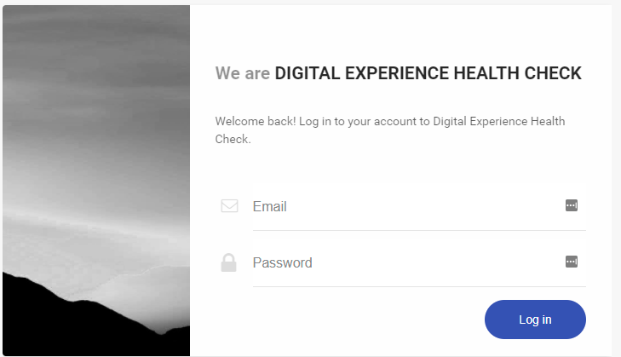

Once logged in, you should be viewing the Study Worklist. From here you will find the data of this patient.

1.5. Study Worklist

From this Study Worklist, the user will find different options to operate the data.
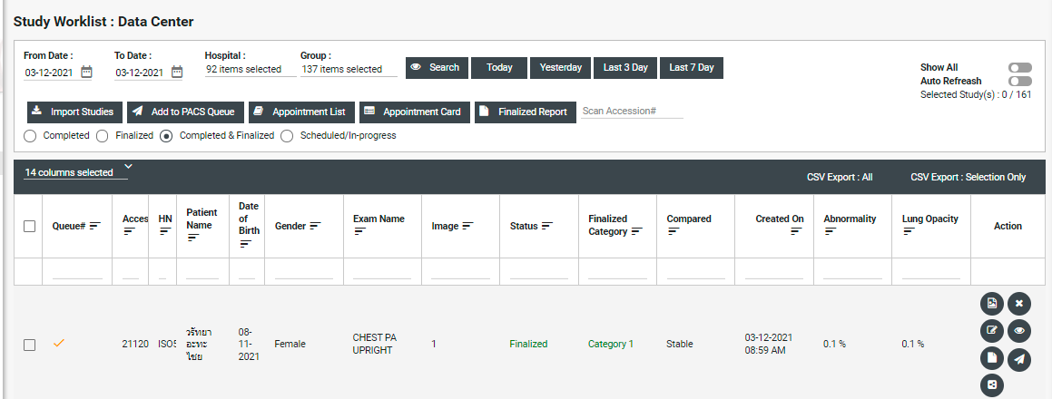
In the left corner, the user will find the Study Worklist.
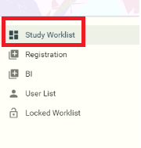

1.6. Understanding the Features
Before you can start to use Digital Experience Health Check, it is imperative that you learn about the small features that are incorporated throughout the application for ease of use, convenience, and better user experience.
The most default feature you will find in almost any tabulated information list is the Column Settings option. Here’s how you see it:
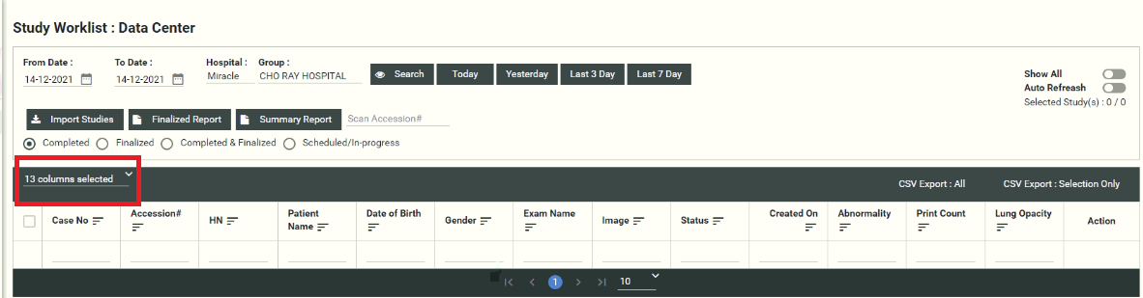
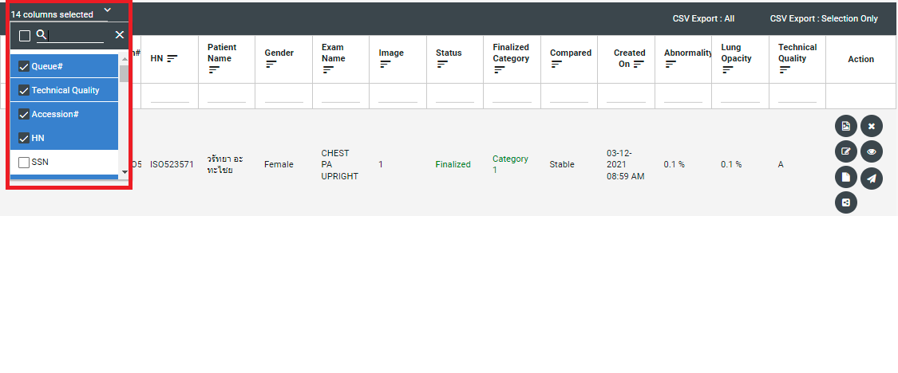
Hospital: Here the user can select items from the dropdown.

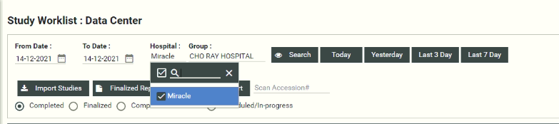

Group: Here the user can select group items from the dropdown.

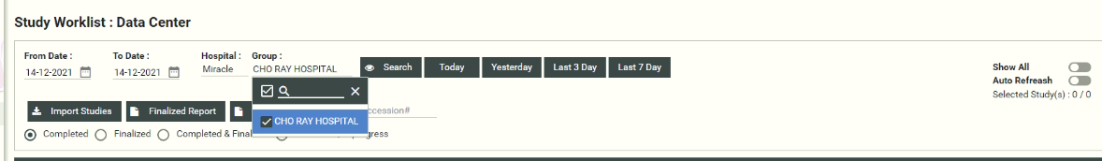

Show All: The user can find all types of status by simply clicking to Show all toggle button in the right corner of the application.

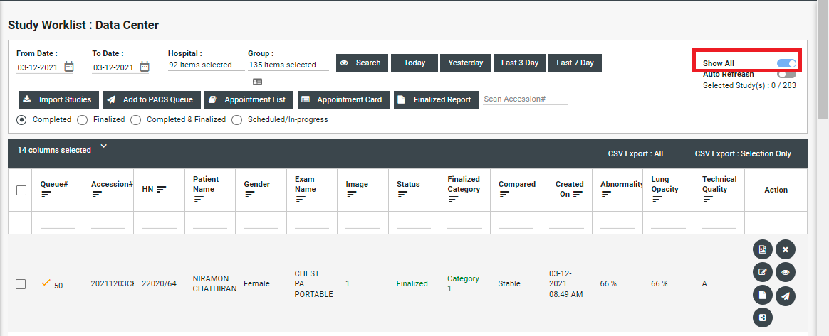

Scan Accession:

The user can scan the accession right after the registration for showing the arrival schedule of the patient.

Import Studies

The user can import studies and also download the study Import templates.

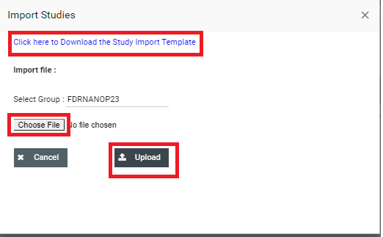

Finalized Report
The user can see the finalized report by selecting any finalized status.
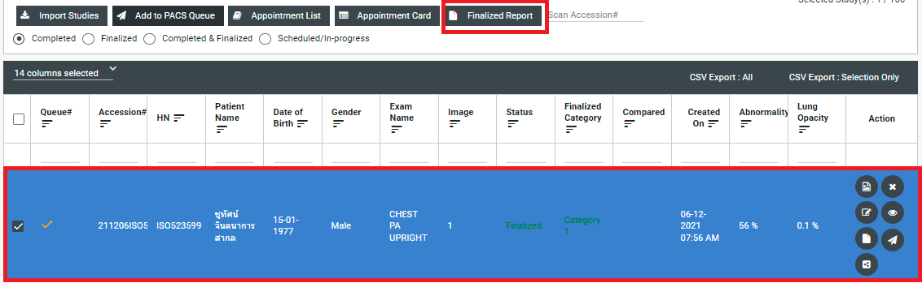
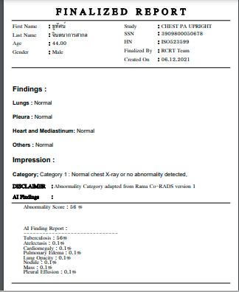

Summary Report
The user can see the summary report by selecting any summary status.

Status
The user can select status individually to see the specific column.

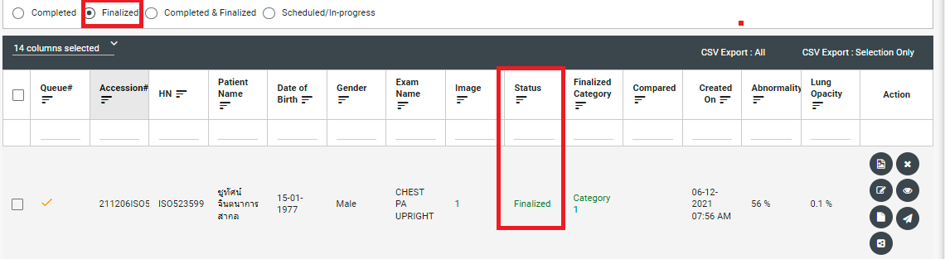

On the right side of the column, the user will find the Action column.
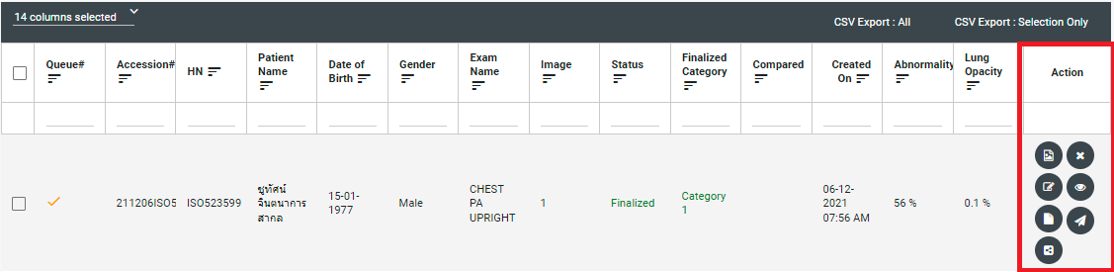

The user will find some buttons in the Action column.
.
- View AI Image
- Cancel
- Reconcile
- View Result
- Copy Shareable Link

View AI Image
The user can see the AI image by clicking the View AI Image.
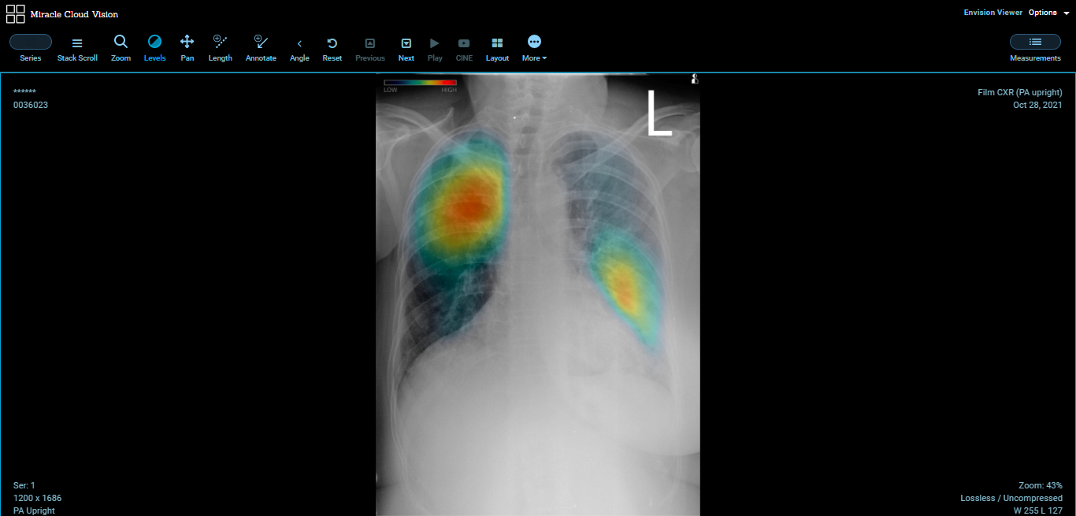

This is a DICOM image, where the AI marks the abnormal area and gives the output.

The user will find the AI findings by clicking the View Result.

Cancel
This action helps to remove the study from the existing column. After clicking the button,  the user will get a confirmation pop-up. Also, you have to provide a reason for canceling the study.
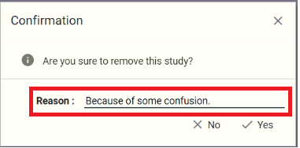

Reconcile
The user can update study info by clicking Reconcile button.
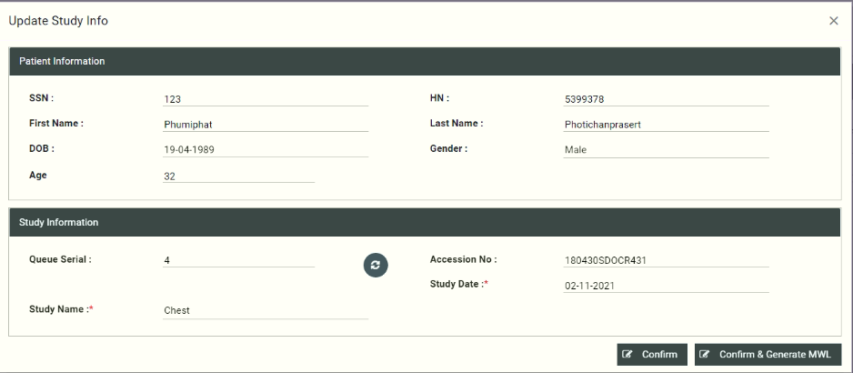

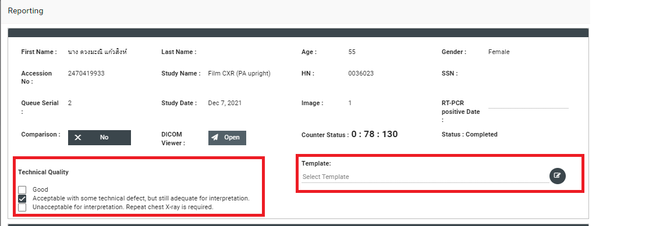
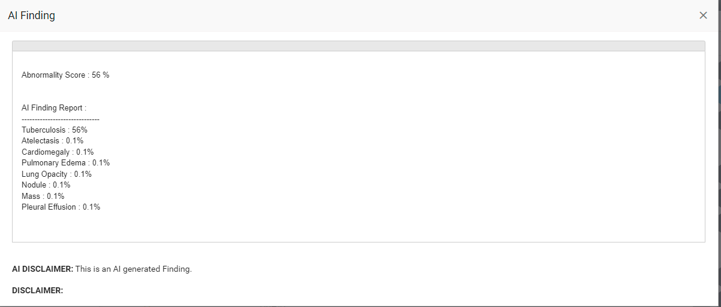

When the user doubles click the column, they will find Reporting Page and Envision DICOM Viewer.
They will first see the patient details and can select the Technical Quality based on AI Findings. Moreover, they can select Template.



In below, the user will find some options.
- AI/History
- Finding
- Impression

AI/History
Here, the user will find the AI Findings of the patient which are detected by the AI.
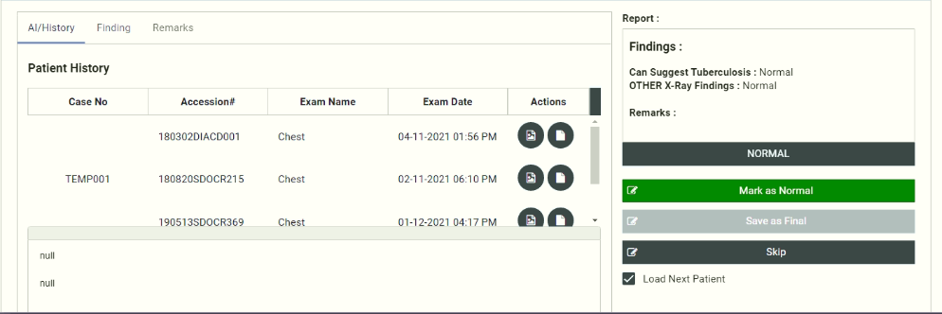

From Patient History, the user can View AI Images and Report.

The user can select findings by own if needed. However, AI has already provided the findings.

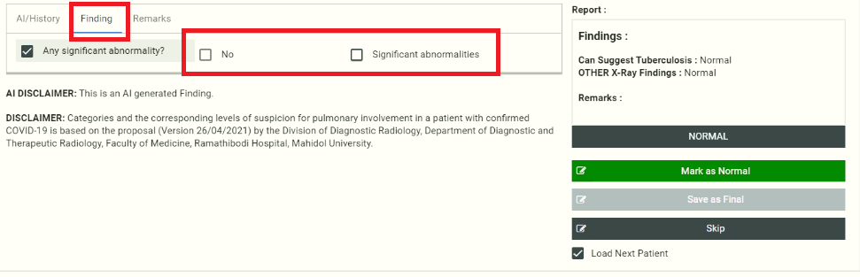
If the user clicks the check box of Significant abnormalities then the user will find some other abnormalities. They can select those abnormalities with the patient’s conditions.
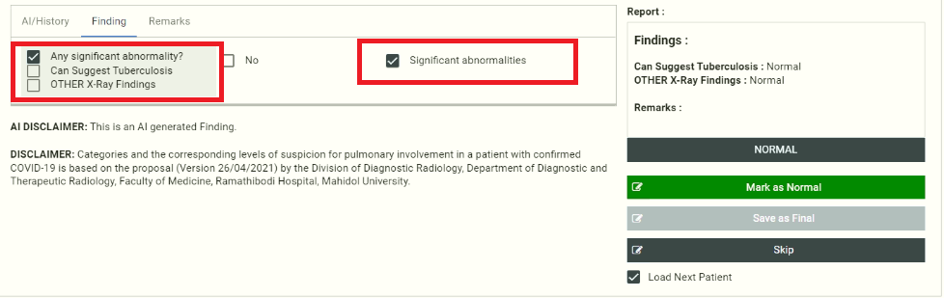
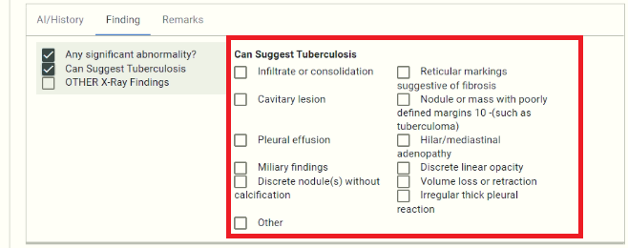
When the user selects any of the findings from Can Suggest Tuberculosis, the button Save as Final will appear.
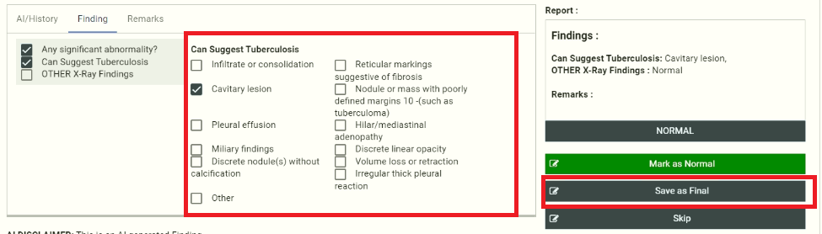

Otherwise, the button becomes blurred.
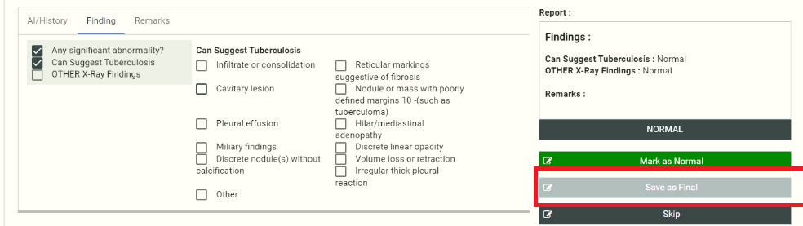
Remarks

In this section, the user can give remarks to the patient. This remark will be added to Report.
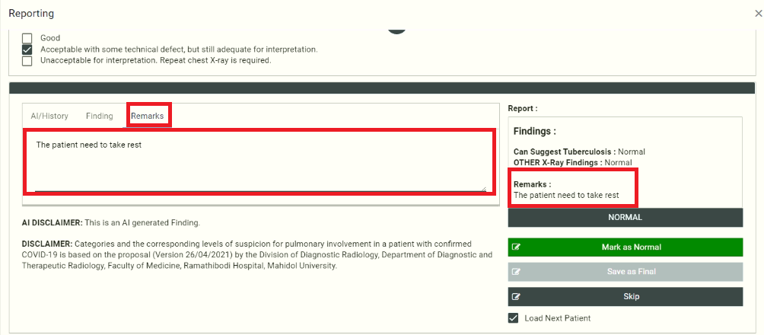

2. Registration
In this section, the user can register for the study.
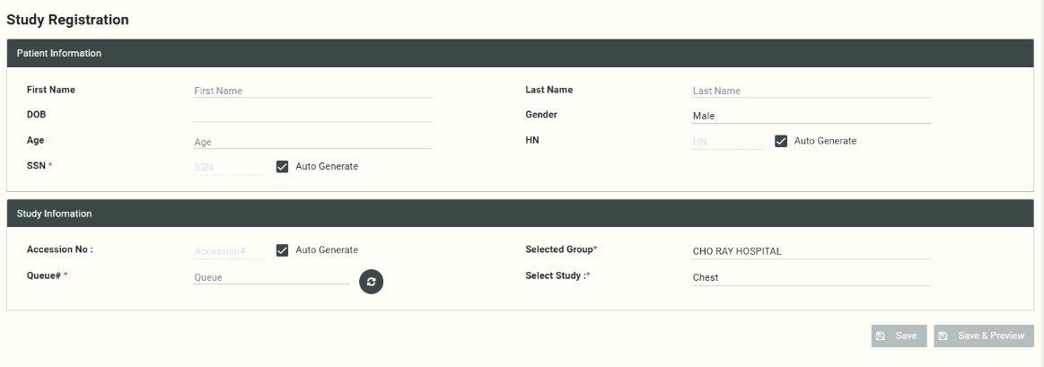
Note: * Mandatory Field

HN, SSN, and Accession No will be auto-generated when the user clicks the checkbox.

4. BI
In this Business Intelligence section, the user will get raw data and statistical data for better visualization.
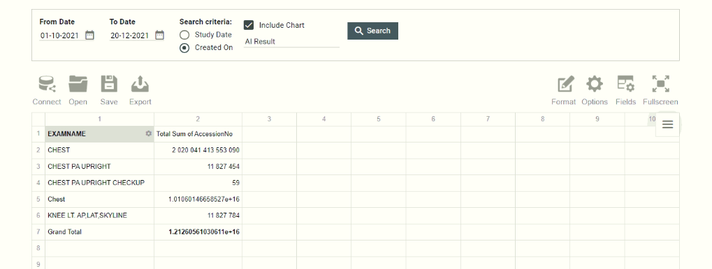

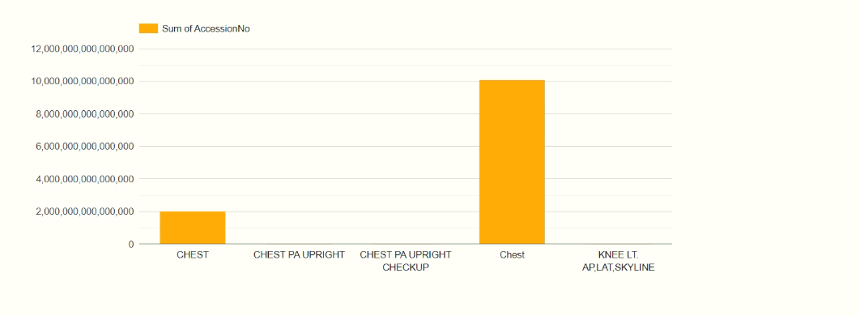

In the first part, the user can search data, From Date -To Date. They can also select whether they want to see Study Date and Created On from the Search Criteria. Also, the user can select the Include Chart option to view the visualization of the data.

In the left corner users will find some functions like- Connect, Open, Save, and Export.

Connect
In this option, the user can connect any data from-
- To Local CSV
- To Local JSON
- To remote CSV
- To remote JSON
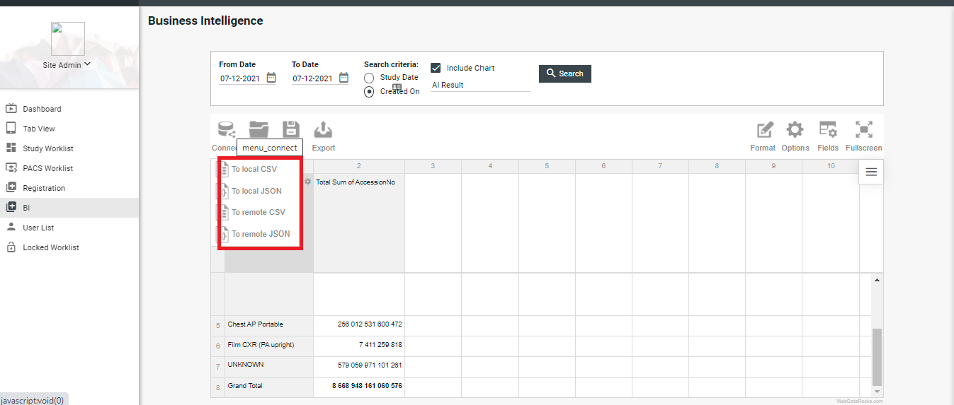

They can also open Local Report or Remote Report from the Open option.

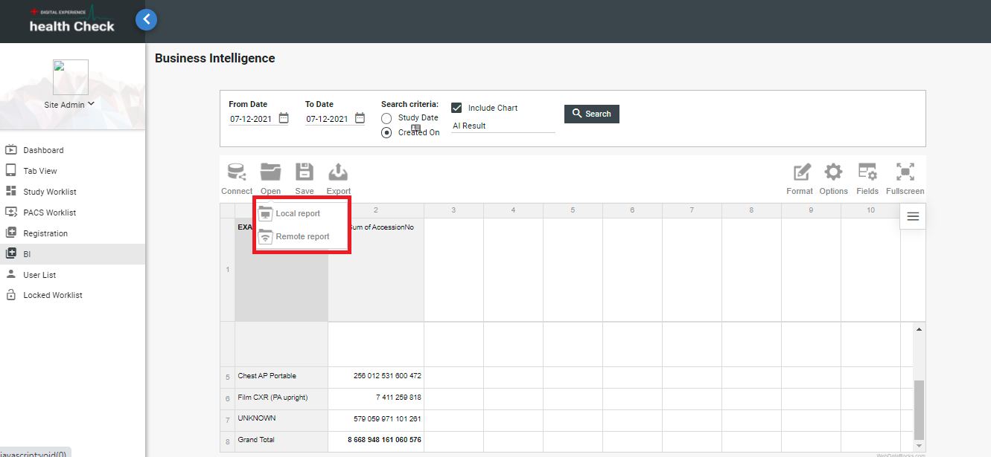

The user can also Print, export to HTML, Excel, and PDF format by clicking on the Export option.
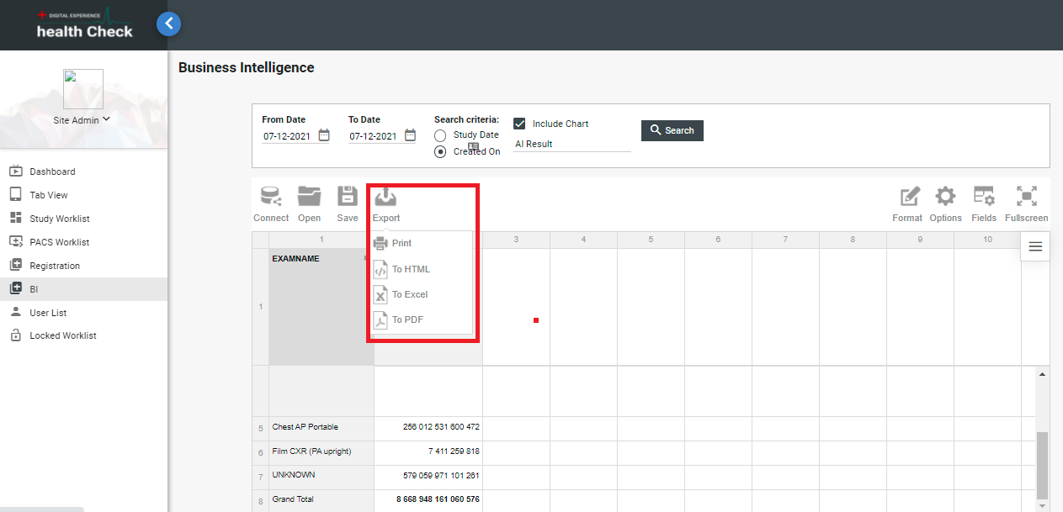

In the right corner, the user will find Format, Options, Fields, and Full-Screen functions.

The user can easily format the data by clicking on the Format. The user will find Format cells and Conditional formatting inside the Format dropdown.
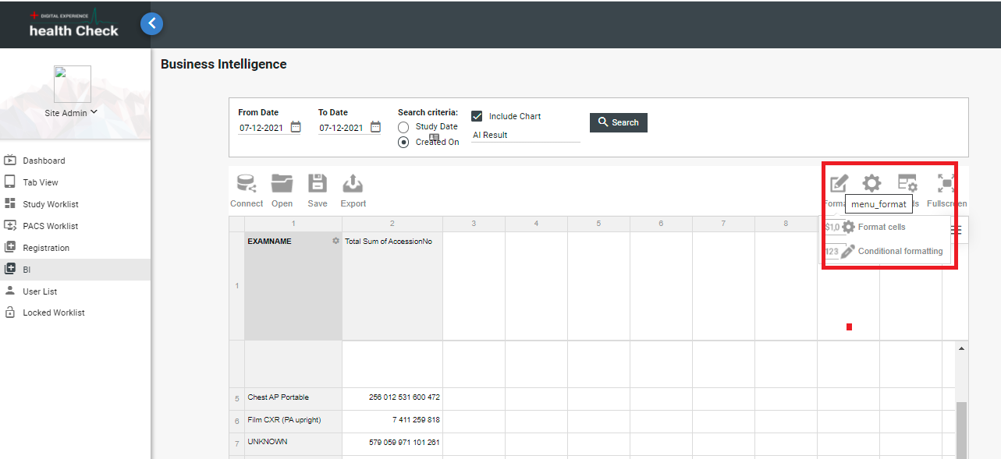
In the Format cells, the user will find some basic format changes options.
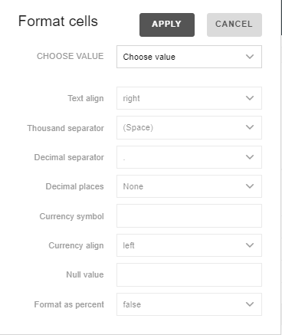

In Conditional formatting, the user will first find a pop-up window where they have to choose the ‘+’ button for further proceeding.
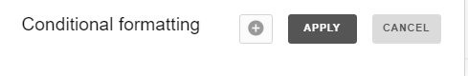
There they can choose the format either less than, less than, or equal, and so on. Moreover, they can also choose a color for those format changes.

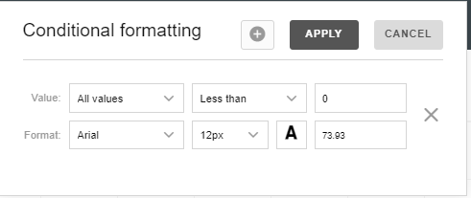

The user can drag and drop fields to arrange the data inside the Fields option.
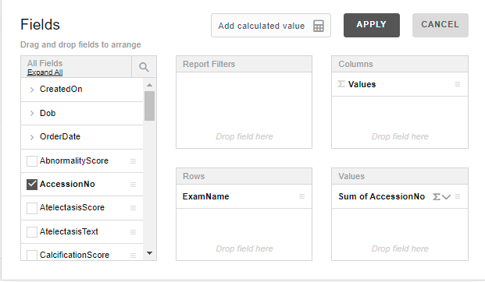

Note: The user can Add calculated value from the Fields.
Finally, they can maximize the screen with the Fullscreen option.

3. User List
You will find the details of User lists from here. Moreover, the user can update any users from the list. Also, they can add new users from the User List.
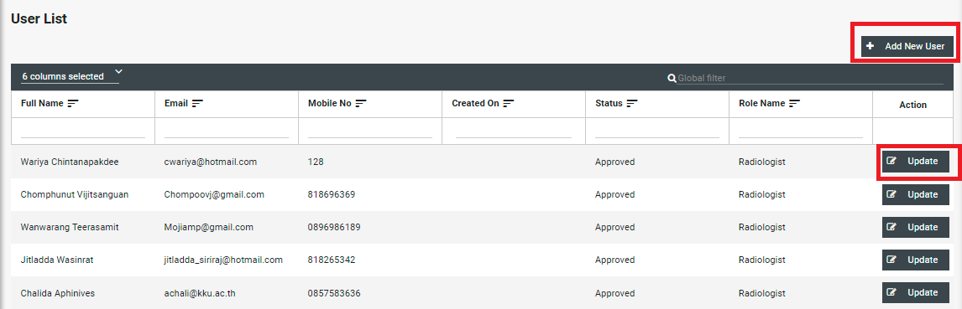

The user will get a form after clicking the Add New User.

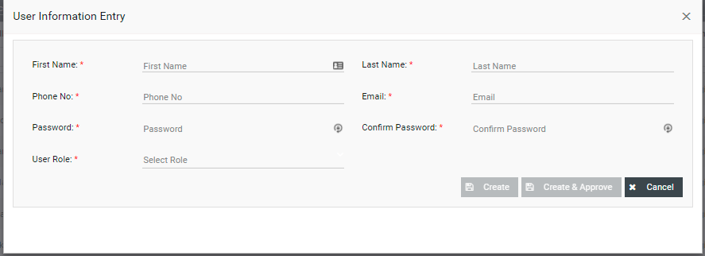

Note: * Mandatory Fields

4. Locked Worklist
The user will get the locked study from the Study Worklist.
